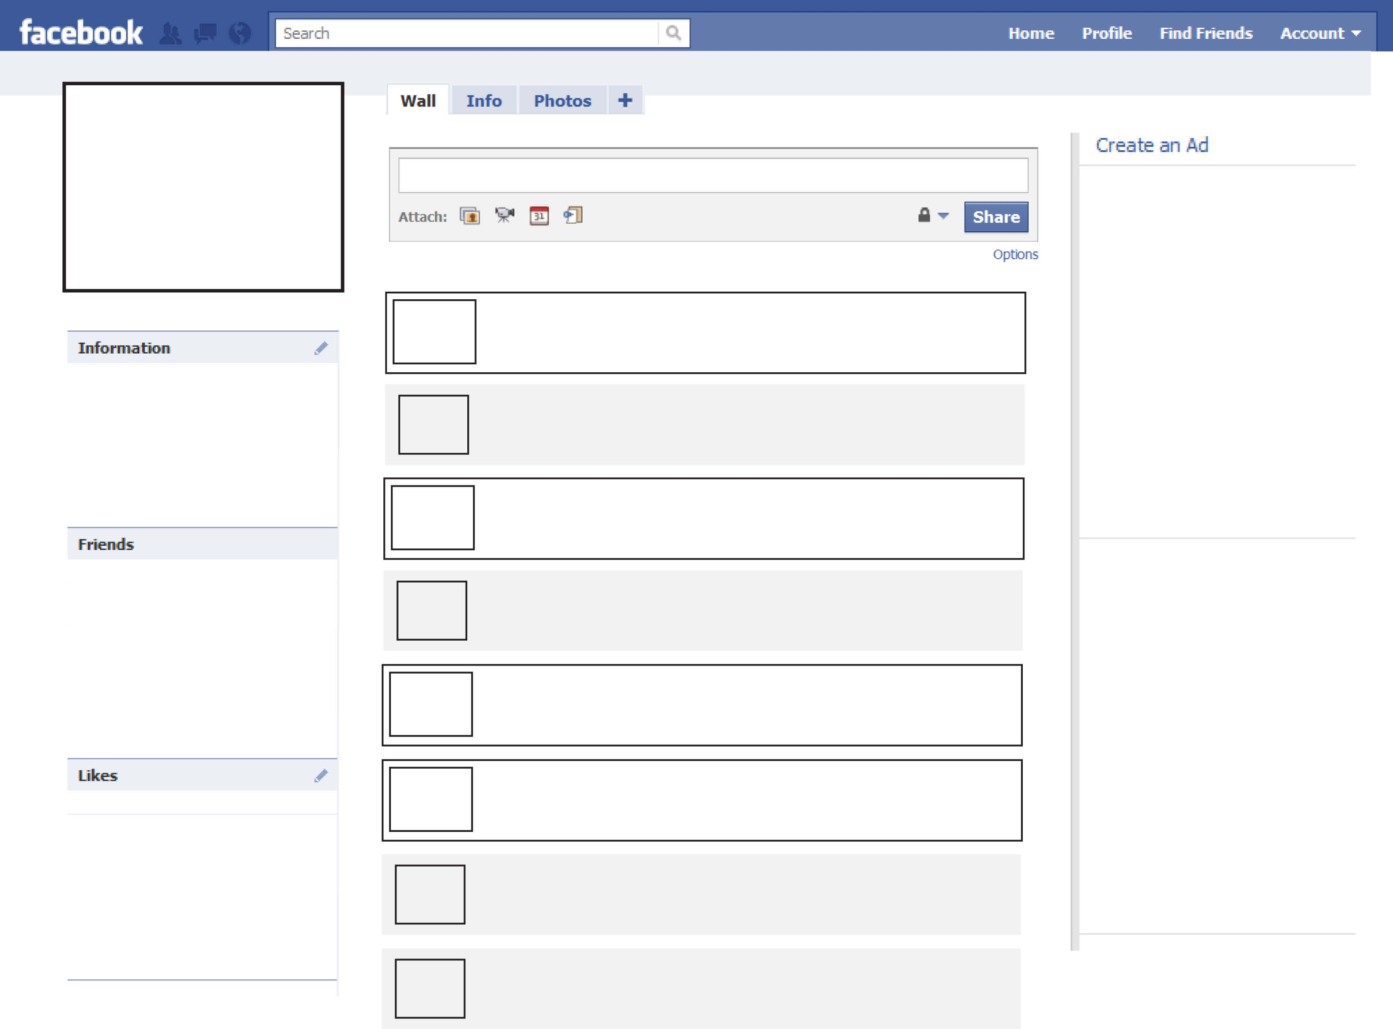

List

Accomplishments

Here

Create an Ad and place it here

(be creative)

Place likely friend’s pictures here. (at least 4)

Place possible likes here.

Put biographical information here.

Type wall post here.

Type wall post here.

Type wall post here.

Type wall post here.

Type wall post here.

Type wall post here.

Type wall post here.

Type wall post here.

Type next wall post here.